
DHOLE PATIL EDUCATION SOCIETY'S

DHOLE PATIL COLLEGE OF ENGINEERING
Accredited by NAAC with A+ Grade, A ISO 9001:2015 Certified Institute
1284, Near Eon IT Park Kharadi, Dhole Patil College Road, Wagholi, Pune-412207 Website: www.dpcoepune.edu.in E-mail:dpcoepune@gmail.com, Phone: 020-66059900

ACA/R / 44 | Department of First Year Engineering | Academic Year: 2025 -26
Rev : 00 |  | Semester: ODD
Date: 15.12.2016 | CCE-I EXAM | Section: A, B, &C
 |  | Subject: Engineering Graphics
Duration : 1Hr |  | Max. Marks: 30

Instructions to candidates 1) Assume suitable data, if necessary.
2) Solve Q. 1 or 2, Q. 3 or 4
3) Each question carries 15 marks.

Q.NO | Question | Marks | BT | CO | PO
1 | 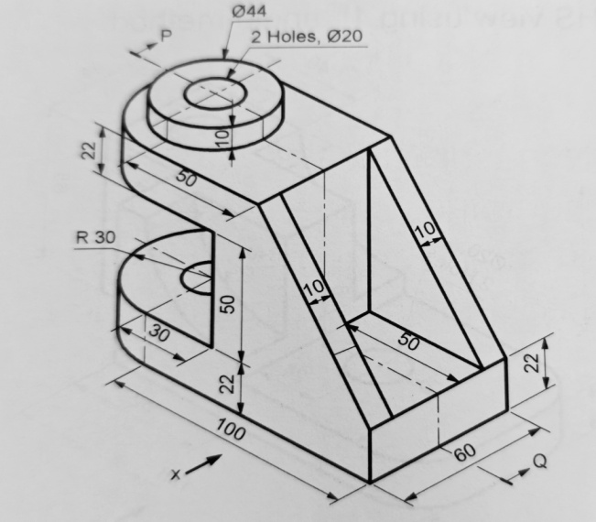 | 15 | 3 | CO4 | PO1
2 | 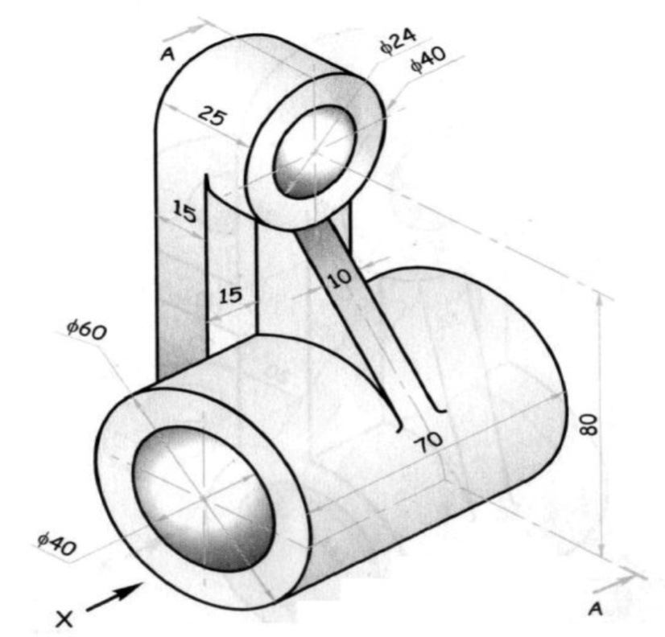 | 15 | 3 | CO4 | PO1
3 | 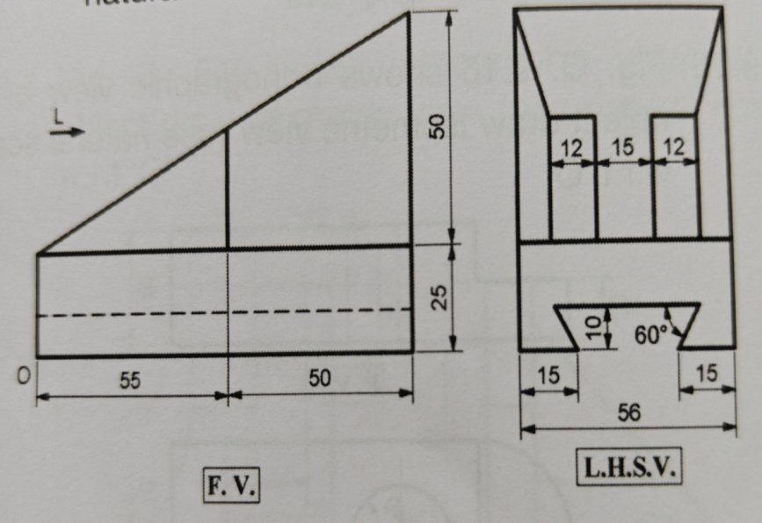 | 15 | 3 | CO5 | PO1
4 | 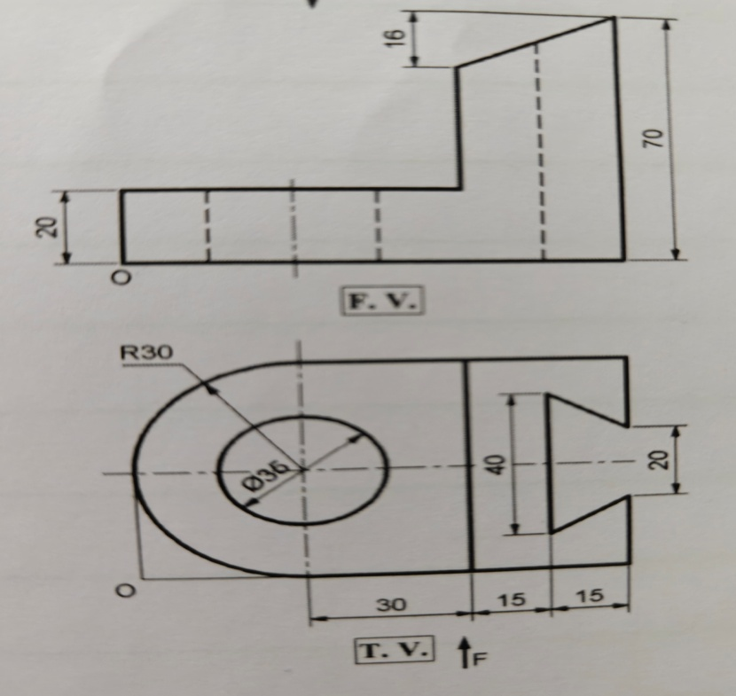 | 15 | 3 | CO5 | PO1

Prof Manisha Kakade Prof Sandip Kale
Subject Teacher Subject Expert

